.

**WINNING PRIZES**

**MENS 1ST PLACE - $1000 CASH AWARD & TROPHY**

**2nd PLACE - $500 CASH AWARD & TROPHY**

**WOMENS 1ST PLACE - $1000 CASH AWARD & TROPHY**

**2ND PLACE - $500 CASH AWARD & TROPHY**

**Friday, July 27**

12:00pm **sharp**

**Turkey Lake Park**

3401 South Hiawassee Rd

Orlando, FL 32835

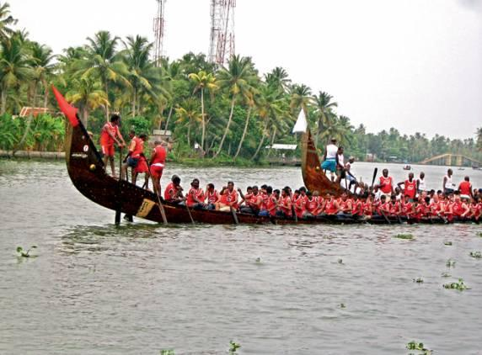

**KCCNA CONVENTION ORLANDO**

**VALLAMKALI**

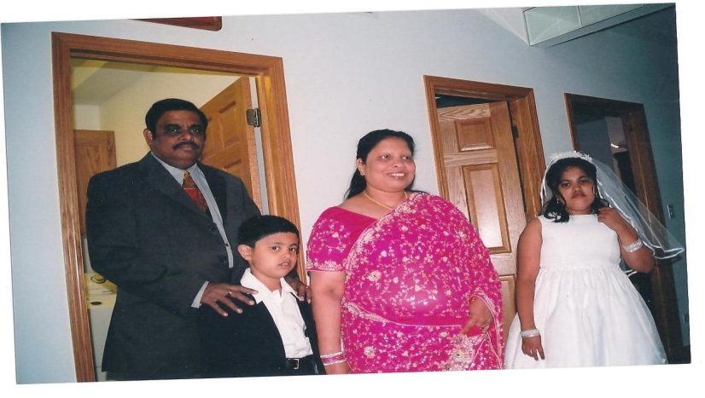

**Time**

**Location**

PROUDLY SPONSORED BY

**DREAM TEAM PRODUCTIONS**

Howly Pottoor & Family

**DREAM TEAM PRODUCTIONS UPCOMING MOVIE MUMBAI DOST**: starring **Prithyraj, Jayasurya, Sarathkumar, Ananya**

directed by: **Rafi-Maccartin**

**Any questions? Please contact:**

**Lovely Karathuruthel (Chair Person) Simon Punnavelil (Co-Chair)**

**(813) 317-7476 (954) 345-0678**